**Q3 All three options—**Imbalanced data**, **Missing values**, and **Outliers**—are common challenges in real-world data. Here's a brief overview of each:**

1. **Imbalanced data**: Occurs when classes are not represented equally, which can lead to biased model predictions.

2. **Missing values**: Data often have gaps, requiring imputation or other techniques to handle these missing values.

3. **Outliers**: These are data points that significantly differ from the rest of the data, which can skew analyses or model training if not addressed properly.

In real-world applications, handling these issues effectively is crucial to building robust models.

**Q4 All three options highlight key reasons why **version control for ML models** is required:**

1. **We might need to deploy a new version of models**: As models are updated with new data or improved techniques, version control allows us to track and deploy these newer versions efficiently.

2. **We might need to roll back to previous versions of models**: If a newly deployed model underperforms or has issues, version control enables us to quickly revert to a stable previous version.

3. **We might want to manage all versions of deployed models**: Tracking different versions allows for better management, traceability, and reproducibility, making it easier to analyze past model performance and compare with newer models.

Version control is essential for maintaining the integrity, performance, and flexibility of ML models over time.

**Q5:**

**ChatGPT:**

**True.** TensorFlow Serving (TF Serving) is designed as a high-performance system for serving machine learning models in production. It can:

1. **Sustain a high load**: TF Serving is optimized to handle large volumes of requests, making it suitable for production environments.

2. **Serve multiple versions of models**: It supports versioning, allowing different versions of a model to be served and easily switched.

3. **Automatically deploy the latest versions**: TF Serving can monitor a model repository and automatically load and deploy the latest model versions when updates are detected.

This makes it a powerful tool for deploying and managing ML models in dynamic production settings.

**Gemini:**

True. TF Serving is a powerful tool for deploying and managing machine learning models in production environments. It offers features like:

* **High Performance:** It can handle a high load of inference requests efficiently.
* **Model Versioning:** It allows you to serve multiple versions of the same model simultaneously, enabling A/B testing and gradual rollouts.
* **Model Repository Integration:** It can automatically detect and deploy new model versions from a specified repository.

These features make TF Serving a valuable tool for deploying and managing ML models in production.

**ChatGPT:**

All three options are valid reasons for **decoupling** the model by wrapping it in a web service rather than directly coding it into the platform:

1. **To easily switch model versions**: Decoupling allows the team to update or replace the model without modifying the entire platform. This enables seamless version management and faster updates.

2. **To easily scale the service independently from the rest of the infrastructure**: By separating the model as a standalone service, it can be scaled up or down based on demand without affecting other parts of the platform. This is crucial for handling variable workloads efficiently.

3. **To simplify testing**: Decoupling allows for isolated testing of the model and its API, making it easier to verify functionality and performance without involving the entire platform. This leads to a more modular and manageable testing process.

Decoupling the model as a web service improves flexibility, maintainability, and scalability of the system.

**Gemini:**

All of the above (To easily switch model versions, To easily scale the service independently from the rest of the infrastructure, To simplify testing) are valid reasons for decoupling the model into a web service.

By wrapping the model in a web service, the team can:

* Easily switch model versions: If a new, improved model becomes available, it can be deployed to the web service without affecting the rest of the infrastructure.
* Easily scale the service independently: The web service can be scaled up or down as needed to handle increased or decreased demand, without impacting the rest of the platform.
* Simplify testing: The web service can be tested independently of the rest of the platform, making it easier to identify and fix issues.

By decoupling the model, the team can make the overall system more flexible, scalable, and maintainable.

Q7:

**Gemini:**

True. A SavedModel in TensorFlow is a self-contained bundle that encapsulates the trained model's architecture, weights, and biases. It represents a specific version of the model, allowing for version control, deployment, and sharing.

**ChatGPT:**

**True.**

In TensorFlow, a **SavedModel** represents a complete and versioned instance of a model, which includes both the model architecture and the trained parameters. Each SavedModel can be used to save, load, and deploy a specific version of a model, making it a versatile format for sharing and deploying models across different platforms and environments.

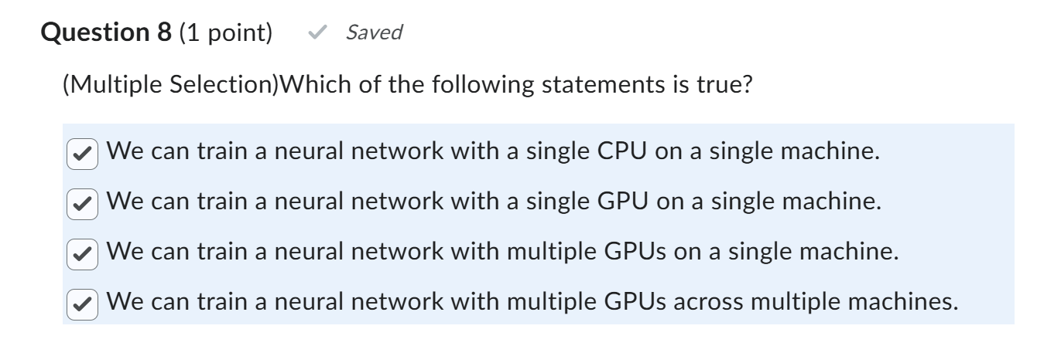

**Gemini:**

All of the above statements are true.

* Single CPU: While slower, it's feasible for smaller models.
* Single GPU: Significantly accelerates training compared to CPU.
* Multiple GPUs on a single machine: Further speeds up training by distributing the workload.
* Multiple GPUs across multiple machines: Enables training of extremely large models that wouldn't fit on a single machine.

**ChatGPT:**

All four statements are true:

1. **We can train a neural network with a single CPU on a single machine**: Neural networks can be trained on a single CPU, although it may be slower compared to GPU-based training.

2. **We can train a neural network with a single GPU on a single machine**: Using a single GPU for training is common and generally provides faster computation than a CPU for many deep learning tasks.

3. **We can train a neural network with multiple GPUs on a single machine**: Many deep learning frameworks, including TensorFlow and PyTorch, support multi-GPU training on a single machine, allowing for parallel processing and faster training.

4. **We can train a neural network with multiple GPUs across multiple machines**: Distributed training across multiple GPUs on different machines is possible and is often used for large-scale models or datasets, leveraging distributed computing to further accelerate training.

Each of these options provides flexibility depending on the resources available and the size and complexity of the model.

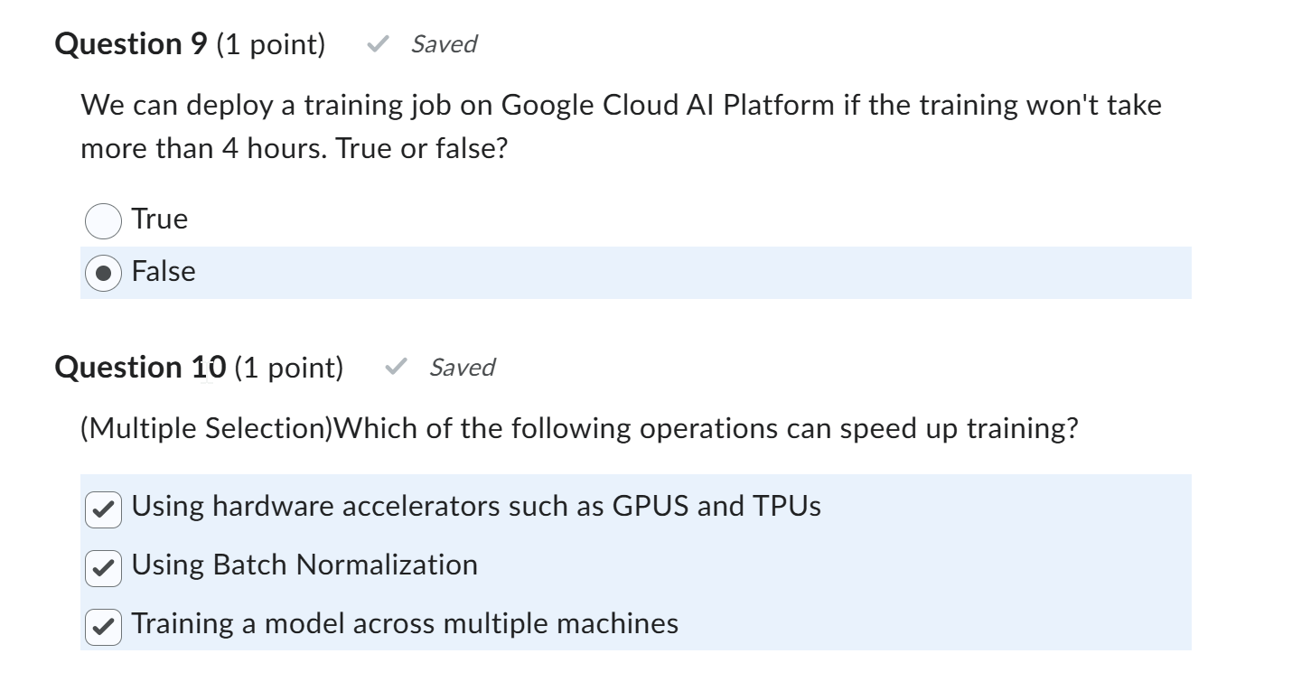

**Q9: ChatGPT:**

**False.**

Google Cloud AI Platform (now part of Vertex AI) allows for training jobs with no specific time limit of 4 hours. You can run training jobs that may take several hours or even days, depending on your resource and budget settings.

**Gemini:**

False. While Google Cloud AI Platform can handle training jobs of varying durations, it's not limited to 4 hours. The platform is designed to accommodate both short and long-running training jobs, allowing you to train complex models that may take days or even weeks to complete.

**Q10:**

**ChatGPT**: All three options can help speed up training:

1. **Using hardware accelerators such as GPUs and TPUs**: Hardware accelerators are specifically optimized for high-performance computation, enabling faster training than CPUs.

2. **Using Batch Normalization**: Batch Normalization helps stabilize and accelerate training by normalizing layer inputs, allowing for higher learning rates and reducing the time to converge.

3. **Training a model across multiple machines**: Distributed training across multiple machines allows for parallel processing of data and model updates, significantly speeding up training times for large models or datasets.

Each of these strategies can contribute to more efficient and faster training.

**Gemini:**

All of the above (Using hardware accelerators such as GPUS and TPUs, Using Batch Normalization, Training a model across multiple machines) can speed up training.

* Hardware Accelerators: GPUs and TPUs are specifically designed for parallel computations, making them ideal for training deep neural networks.
* Batch Normalization: This technique helps stabilize training and can lead to faster convergence.
* Distributed Training: Distributing the training process across multiple machines allows for parallel processing of data, significantly reducing training time.